Alpine Skiing App

User Manual

To use with web application you must have a device that is connected to the internet. This will be usable both on mobile devices, PC’s and Mac’s.

Inputting data

Step 1: Open your preferred web browser on your device

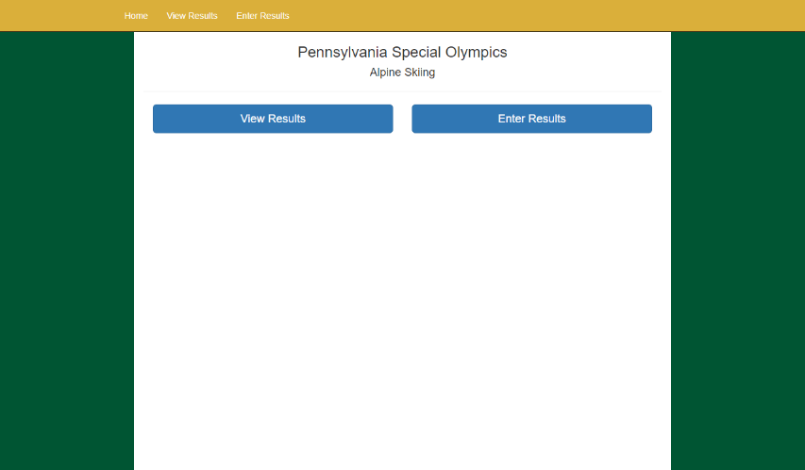Step 2: In the address bar, type 198.199.120.65 and hit enter. This will bring you to the web app’s home page.

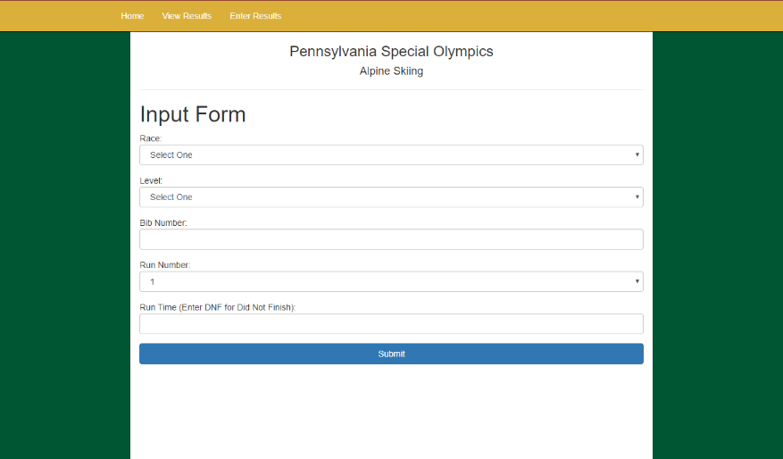Step 3: Click the blue link labeled “Enter Results.” This brings you to the app’s input form.

Step 4: Enter the information you wish to enter into the database.

**Race and Level:** Select from the Race and Level drop down lists.

**Bib Number:** Enter the racer’s bib number in the text box labeled “Bib Number.”

**Run Number:** Select from the Run Number drop down the list. Note that a Run 1 time must be entered before a Run 2 time may be entered. A Run 2 time may also not be entered if the racer did not finish the first run. Also, each racer may only have one Run 1 time per Race and Level combination.

**Run Time:** Enter the run time in the text box labeled “Run Time” with the format “minutes:seconds:milliseconds” If the racer did not finish, enter “DNF” in all capital letters.

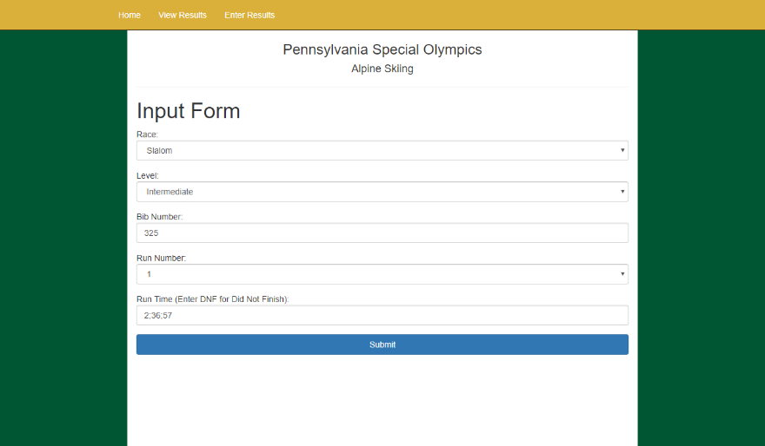Example

Step 5: At the bottom of the form click the button labeled “Submit” to submit the record to the database. Upon completion you will alerted whether the submission was successful or not.

View Results

Step 1: Open your preferred web browser on your device.

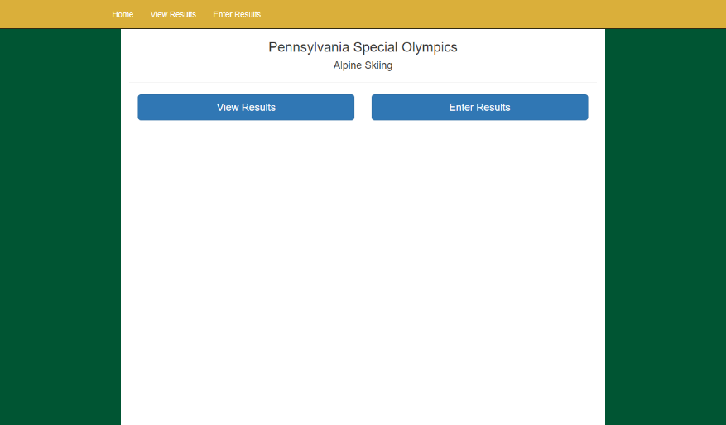Step 2: In the address bar, type 198.199.120.65 and hit enter. This will bring you to the web app’s home page.

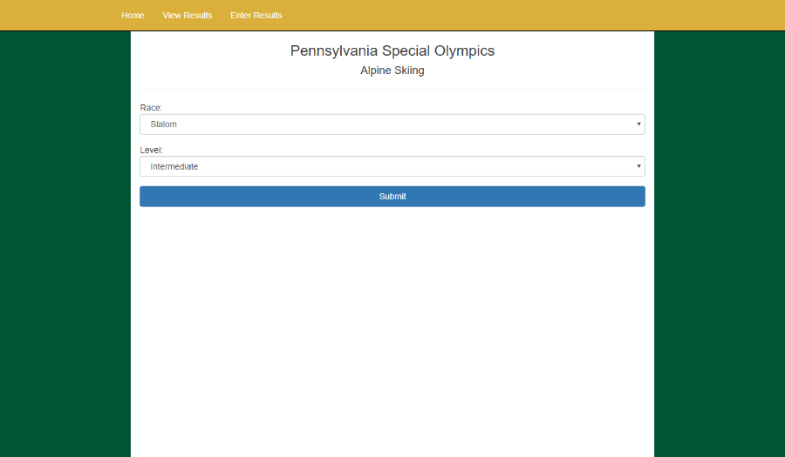Step 3: Click the button labeled “View Results.” This brings you to a page with two sorting options.

Step 4: Using the two drop down lists for race and level select the level and race for the results you wish to view.

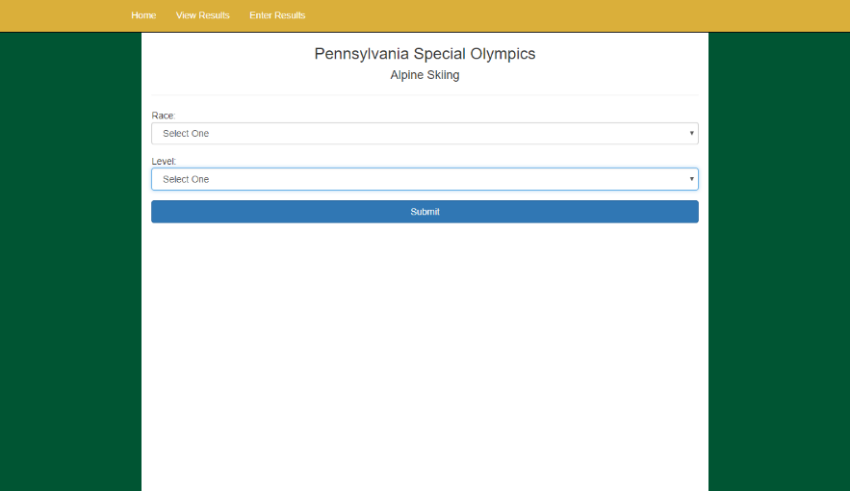Example

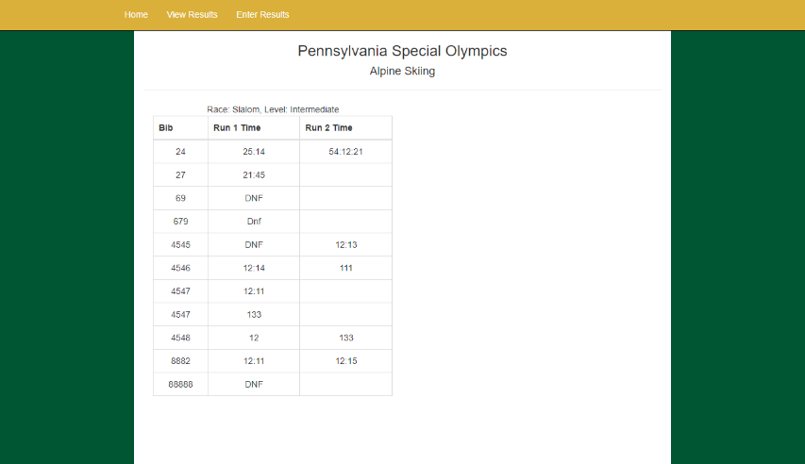Step 5: Click the button “submit” to finalize which racer and level you want to view. This will return to the page a table of records of results in the database for the corresponding race and level you had selected.